**WEEK-2 Flow Control Statements**

**NAME:ENIYA.B.A**

**ROLL NO:230701085**

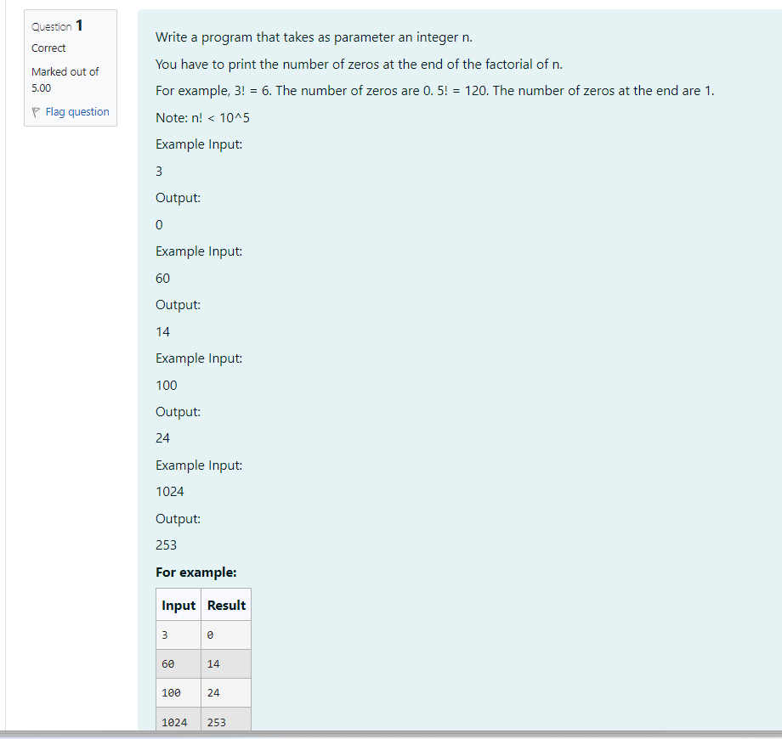

**CODE:**

import java.util.*;

public class Zeros{

public static int countz (int n){

int count=0;

for(int i=5;n/i>=1;i*=5){

count+=n/i;

}

return count;

}

public static void main(String[] args){

Scanner sc=new Scanner(System.in);

int n=sc.nextInt();

int r=countz(n);

System.out.println(r);

}

}

OUTPUT:

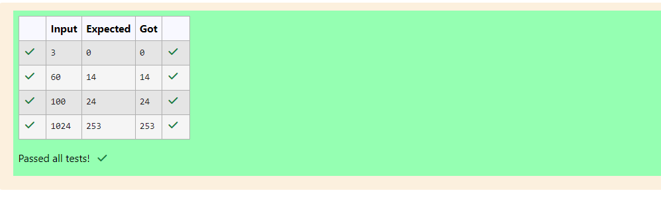

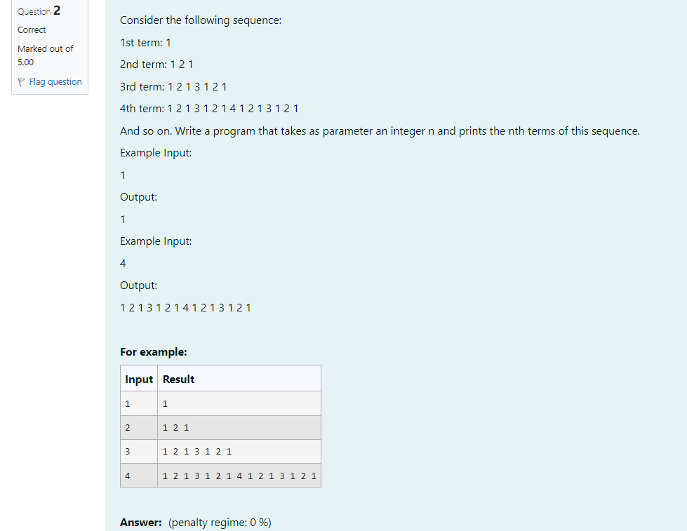

CODE:

import java.util.*;

public class Sequence{

public static void main(String[] args){

Scanner sc=new Scanner(System.in);

int n=sc.nextInt();

if(n==1){

System.out.print("1");

}else if(n==2){

System.out.print("1 2 1");

}else if(n==3){

System.out.print("1 2 1 3 1 2 1");

}else if(n==4) {

System.out.println("1 2 1 3 1 2 1 4 1 2 1 3 1 2 1");

}else if(n==5){

System.out.println("1 2 1 3 1 2 1 4 1 2 1 3 1 2 1 5 1 2 1 3 1 2 1 4 1 2 1 3 121");

}

}

}

OUTPUT:

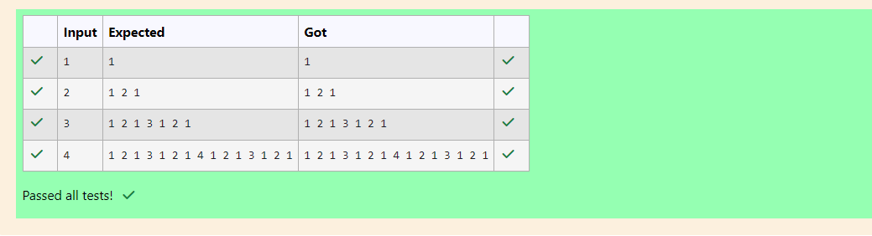

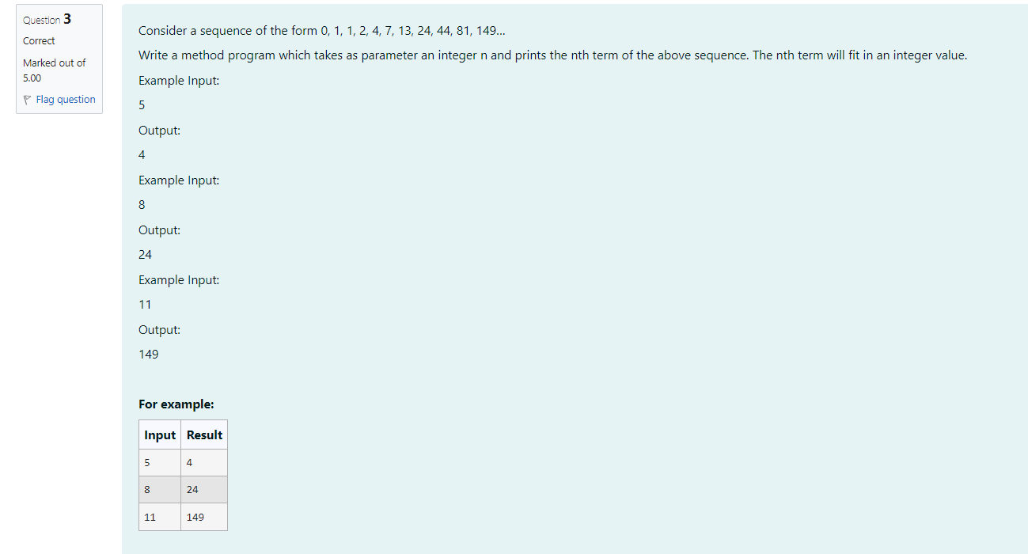

CODE:

import java.util.*;

public class Main{

public static void main(String[] args){

Scanner sc=new Scanner(System.in);

int n=sc.nextInt();

if(n==0||n==1)System.out.println(n);

else if(n==2)System.out.println(1);

else{

int m=0,p=1,q=1, temp=0;

for (int i=3;i<n;i++){

temp=m+p+q;

m=p;p=q;q=temp;

}

System.out.println(q);}}}

OUTPUT:

